**Groupassignment Presentation**

In both weeks of our exchangeprogram the students have to present a part of the week on the evening when their parents are being invited.

On Tuesday 10 februar and Tuesday 10 march the group of students will be divided into ten groups.  
(8 groups of 4 persons (2 Dutch and 2 Catalans and 2 groups of 5 persons (2 Dutch and three Catalans)).

Every group has to collect during the exchange week a lot of information about their theme, make pictures of the field trips, etc.  
In Spain the groups have to set up a glogster.   
You can find more information on the next website: <http://edu.glogster.com/>

For the presentations in the Netherlands every group is free to choose a way to present, it alsco can be a glogster, a prezi-presentation, a powerpoin-presentation of any other creative form of presentation.

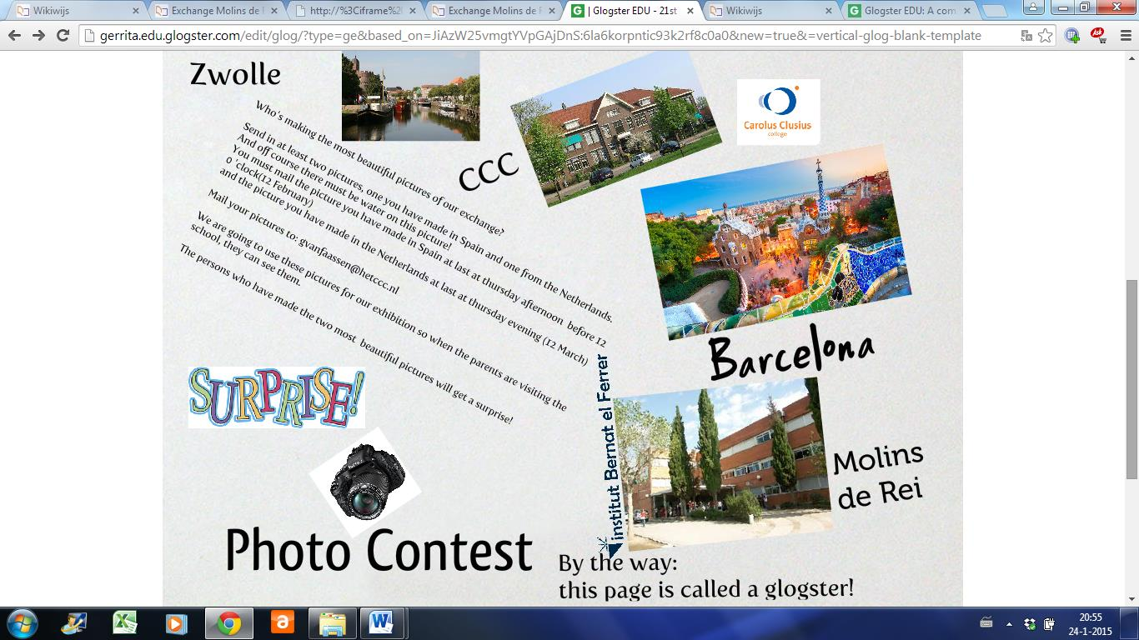. 



**Or other creative ideas!!!**